NAME : DANJUMA ALICE OMALI

MATRIC /NO: UJ/2024/NS/0208

INSTITUTION : UNIVERSITY OF JOS

DEPARTMENT : COMPUTER SCIENCE

PROJECT TITLE: NETWORK DISCOVERY AND TRAFFIC ANALYSES

INTRODUCTION
This project demonstrates network discovery on my workstation via HHUAWEI hotspot.
Tasks: hostname, ip, MAC, gateway, DNS, ping,nslookup, traceroute, wireshark ICMP/DNS.

TASK 1: WORKSTATION AND NETWORK INTERFACE
- Hostname-----DESKTOP-QCTU0J0
- Ipv4:192.168.43.1
- Mac:4a:47:98
- Gateway:192.168.43.1
- Network interface used: WI-FI(wireless LAN)

- W3_Task1_evidence_01
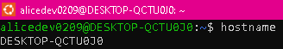
- W3_Task1_evidence_02
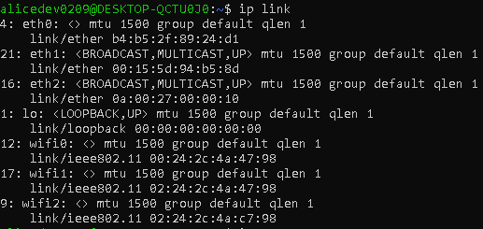

- W3_Task1_evidence_03
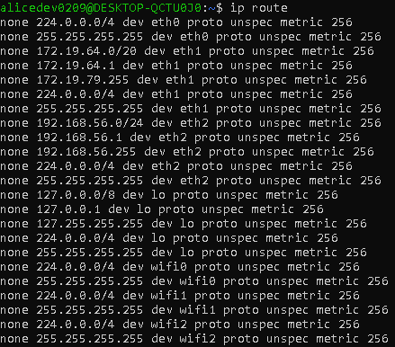

TASK 2:DNS INFORMATION
1. Hostname:DESKTOP-QCTU0J0
2. Ipv4:192.168.43.1
3. Mac address:4a:47:98
4. Default Gateway:192.168.43.1
5. Network interface:WI-FI
6. DNS server address--- 192.168.43.1

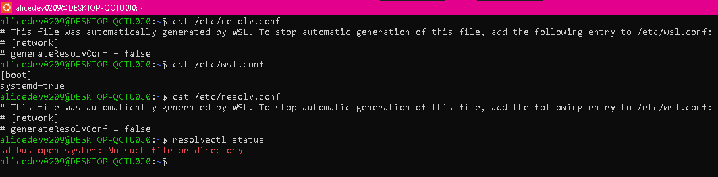

TASK 3:CONNECTIVITY
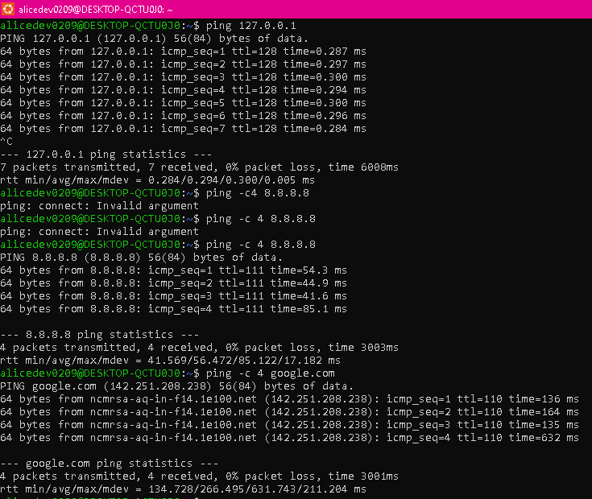

TASK 4:DNS LOOKUP
- Domain Queried---- google.com
- DNS server used----192.168.43.1
- Ip address----- 142.250.129.100

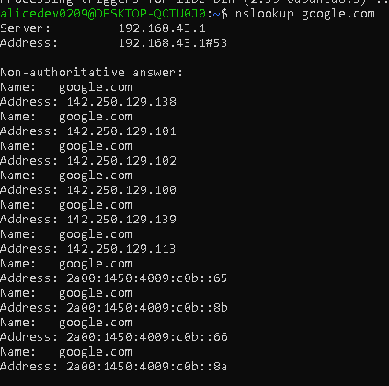
*DNS translated google.com from human readable language to ip address.
TASK 5:ROUTE INVESTIGATION
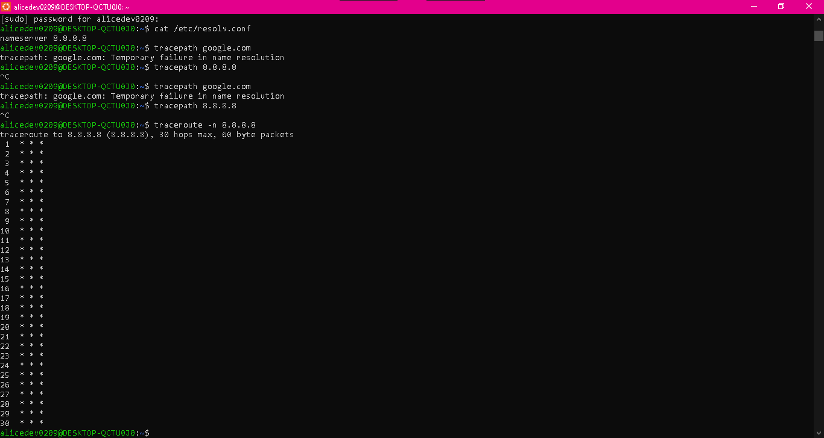

Number of visible hops: 30
What a hop represent: A router forwarding packets.

Task 6: WIRESHARK ICMP CAPTURE
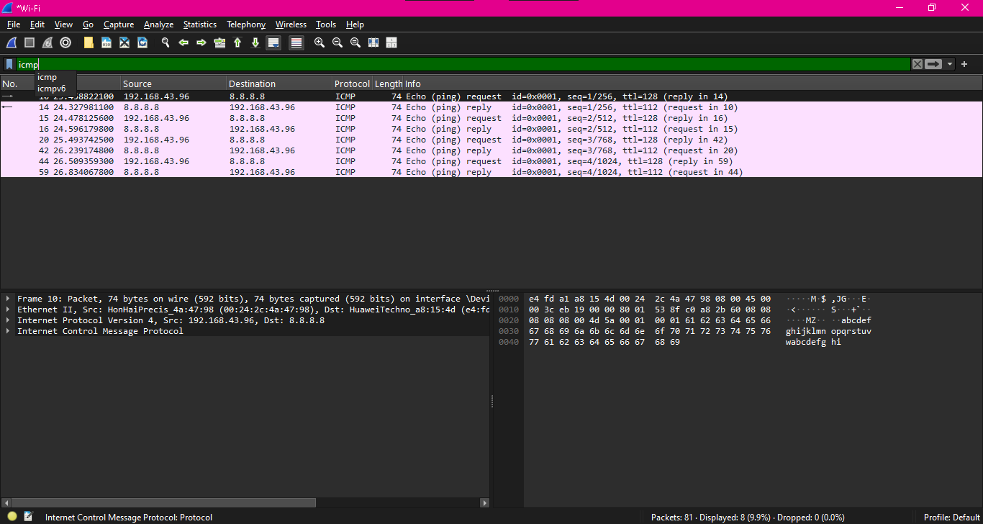
INFORMATION | ECHO REQUEST | ECHO REPLY
Packet number | 10 | 14
Source ip | 192.168.43.96 | 8.8.8.8
Destination ip | 8.8.8.8 | 192.168.43.96
Protocol | ICMP | ICMP
Type | Echo Request len 74 | Echo reply

Task 7:WIRESHARK DNS CAPTURE
INFORMATION | RESULT
Source ip | 192.168.43.1
Destination ip | 8.8.8.8
Requested domain | Google.com
Returned ip address | 192.168.43.96

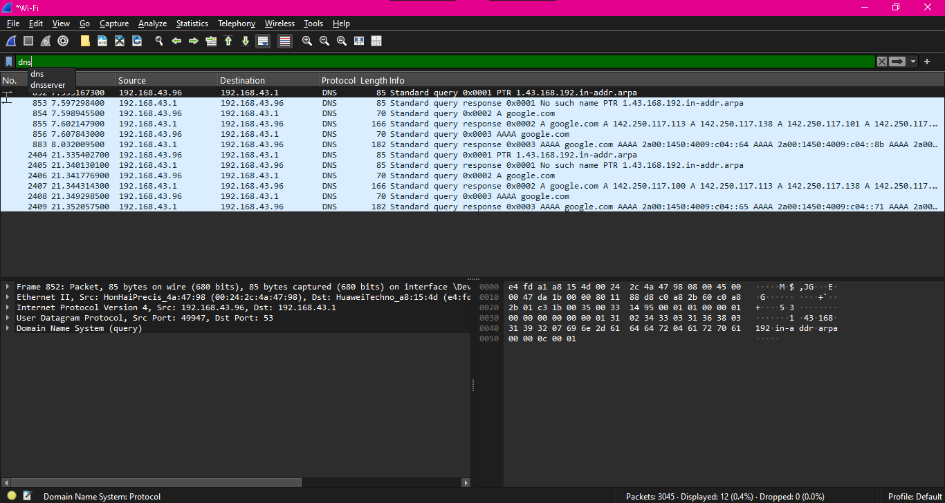

Task 8:
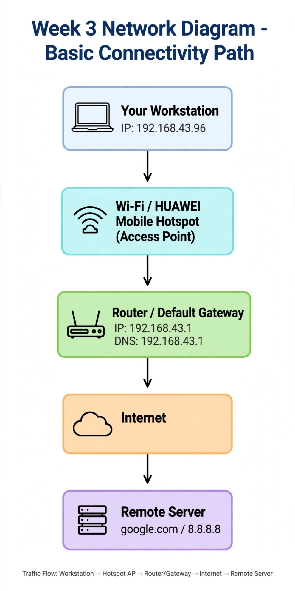
SECURITY OBSERVSTION QUESTIONS
- Purpose of Ip address: Logical identifier to locate host and route packets.
- IP vs MAC Address:
- Purpose of Default gateway: Forwards packets from local LAN to External networks/internet.
- What DNS does: Translates human names to ip addresses.
- Failed ping misleading: Firewall may block ICMP but host up; congestion/limiting.
- Wireshark ICMP: I saw Echo Request/Reply, ips,96 <> 8.8.8.8 protocol ICMP, Lengthn, time.
- DNS Query/Response: Query a google.com .96->1, response .1->96 with IP, also PTR and AAAA
- Why inspect network traffic: Detects threats, troubleshoot, verify security policies,learn protocols
- Only authorized capture:Privacy,legal,ethics,cannot captureothers traffic without consent.
- Most useful: understanding DNS as 192.168.43.1 and using display filters icmp/dns-makes invisible traffics visible.

Conclusion : This project provided hands on practical experience with basic network discovery and traffic analysis .

